
Renewed Surface Water Management Program:
Priority Construction Projects Sub-Program

The renewed Surface Water Management Program (SWMP) in the Shepparton Irrigation Region (SIR) has seen the planning and construction of a number of priority primary and community surface water management systems (SWMS).

The SIR Drainage Strategy was reviewed in 2015 and identified key priority sub-catchments requiring drainage based on a range of economic, social and environmental criteria.
The SIR Drainage Working Group identified two primary SWMS and two community SMWS as priority construction projects that could be delivered in the short term. These four projects had strong community support, significant prior investment, including completed designs, and were located in sub-catchments with historic drainage issues.
The four selected priority construction projects were recommended by the SIR Drainage Working Group and endorsed by the Shepparton Irrigation Region People and Planning Implementation Committee (SIRPPIC).
Landholders involved in these priority construction projects were engaged to confirm support for construction and determine cost-share arrangements (in the case of community SWMS).
Approved SWMS were constructed by Goulburn-Murray Water, with landholder extension and engagement being undertaken by Agriculture Victoria irrigation farm services and Goulburn-Murray Water.
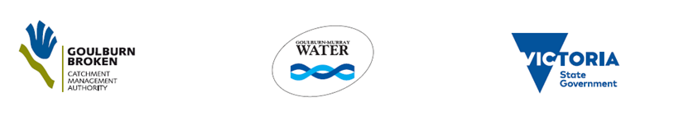
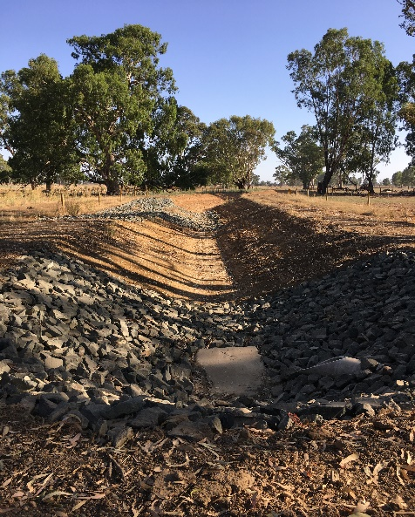
Mosquito Drain 40 Primary SWMS

The completed Primary SWMS are:
Mosquito Depression Drain 40: completed February 2019, length 4.1 km, area served 567 ha.
Stanhope Depression Drain (Stage 2): completed December 2017, length 13.6 km, area served 1,250 ha.

The Community SWMS are:
Muckatah 2/3P: completed April 2019, length 4.6 km, area served 630 ha.
Muckatah 3/8P: in progress (currently in the planning stage).
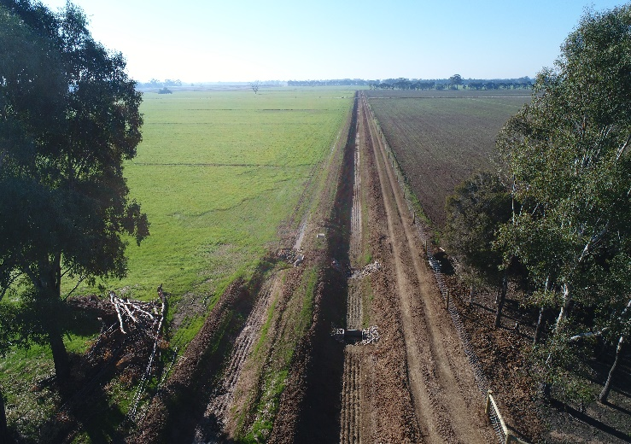
Muckatah 2/3P Community SWMS
The delivery of priority construction projects has occurred in conjunction with other sub-programs. One sub-program is establishing SWMS which are based on restoring flow in natural drainage courses, while the other is focussing on initiatives to improve drainage on-farm.
These other sub-programs are currently being implemented by Goulburn Broken CMA, Goulburn-Murray Water and Agriculture Victoria to ensure the best outcomes for the region with the available funding.
For further information please contact:
Goulburn Broken CMA
Telephone: 5820 1100
PO Box 175 Shepparton 3632
reception@gbcma.vic.gov.au

